


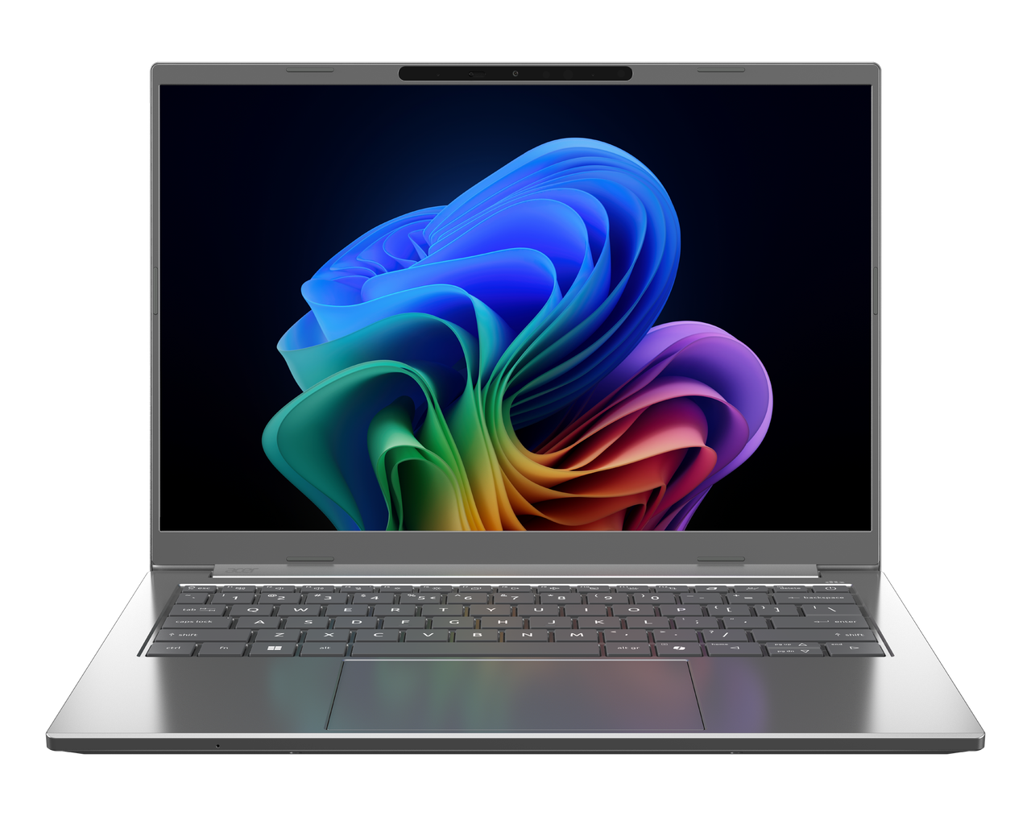

Aspire 14 AI
SPECIFICATIONS Aspire 14 AI A14-I71M, A14-I71MT
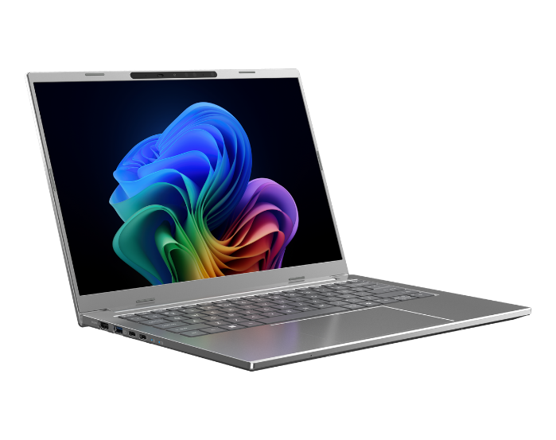
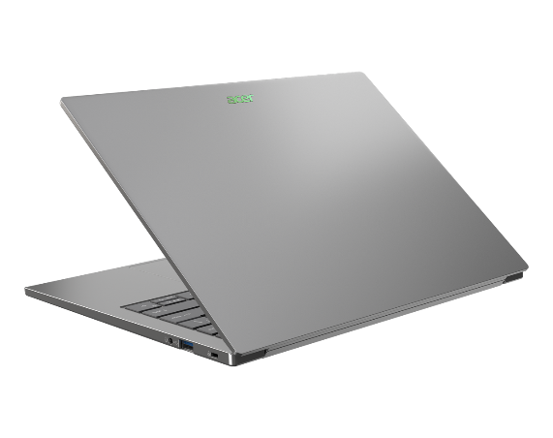
1
4
3
2
1

5
12
11
Product views | - Microphones  - Camera shutter  - Camera  - IR Camera  - Non-touch/Touch OLED Display¹  - HDMI 2.1 port  - USB 3.2  - Thunderbolt™ 4  - Thunderbolt™ 4 |  | - Touchpad  - Keyboard  - Power button  - Audio Jack  - USB 3.2  - Kensington Lock
Operating system¹ | Windows 11 Home / Pro
CPU and chipset¹ | Intel® Core™ Ultra 5 processor 322 | Intel® Core™ Ultra 5 processor 325 | Intel® Core™ Ultra 7 processor 355 | Intel® Core™ Ultra 7 processor 356H  Intel® Core™ Ultra 9 processor 386H
Memory^{1, 2, 3} | Dual-channel LPDDR5X SDRAM support  - 32 GB of onboard LPDDR5X system memory |  | Dual-channel LPDDR5X SDRAM support  - 16 GB of onboard LPDDR5X system memory
Display⁴ | A14-I71M  14.0" display with IPS (In-Plane Switching) technology, WUXGA 1920 x 1200, Acer ComfyView™ LED-backlit TFT LCD, supporting 120Hz refresh rate.  - 16:10 aspect ratio, color gamut sRGB 100%  - Wide viewing angle up to 170 degrees  - Mercury free, environment friendly |  | A14-I71MT  14.0" WUXGA 1920 x 1200 resolution LED-backlit IPS LCD with integrated multi-touch 16:10 aspect ratio, color gamut sRGB 100%  - 16:10 aspect ratio, sRBG 100%  - Super-slim design
Audio | - DTS® Audio, featuring optimized bass response and micro-speaker distortion prevention  - Acer Purified.Voice technology with AI noise reduction in a 3-mic array of built-in microphones, supporting Advanced Privacy Mode, far-field pickup, dynamic noise reduction through neural networks, adaptive beam forming, and pre-defined personal and conference call modes  - High SNR DAC with 2.1 Vrms output capability, capable of driving high-impedance headphones up to 600 ohms  - Acer TrueHarmony Technology for lower distortion, wider frequency range, headphone-like audio, and powerful sound powered by the Acer Ultra Boost Stereo Speaker Module  - Compatible with Cortana with Voice
Storage^{1, 5} | Solid state drive  - 512 GB / 1 TB, PCIe Gen4, 16 Gb/s, NVMe
Webcam¹ | Video conferencing  UFC with:  - Double T-Type USB FHD +IR Camera  - Dual Mic (33 mm + 33 mm)"  - Blue glass lens | - Compatible with Windows only  - 1920 x 1080 resolution  - 1080p HD video at 30 fps with Temporal Noise Reduction  - IR 940nm
Wireless and networking¹ | WLAN  - Intel® Wireless Wi-Fi 6E AX211  - 802.11 a/b/g/n/ac/ax wireless LAN  - Band: 2.4 GHz, 5 GHz and 6 GHz |  | - 2x2 MIMO technology  Support CNVi interface  WPAN  Supports Bluetooth® 5.4 or above `  Supports Bluetooth LE Audio (LC3).
Dimensions and weight^{7,8} | Dimensions: •312.4 (W) x 225.9 (D) x 11.6/15.8 (H) mm (12.3 x 8.89 x 0.46/0.62 inches)  Weight: •1.25 kg (2.76 lbs.) with 3-cell battery pack, one SSD
Power adapter and battery^{9,10} | A14-I71M | A14-I71MT  Power adapter  3-pin 100 W PD PCR 50%, TCO 9.0 AC adapter  •5 V / 3 A or 9 V / 3 A or 12 V / 3 A or 15 V / 3 A or 20 V / 3.25 A as output power"  •108.0 (W) x 56.0 (D) x 26.5 (H) mm (4.25 x 2.20 x 1.04 inches)"  •296 g ± 5% with 150 cm DC cable  •Black color with Acer logo  •Brick type AC pins"USB Type-C 65 W PD PCR 50%, TCO 9.0 AC adapter  USB Type-C 65 W PD PCR 50%, TCO 9.0 AC adapter  •5 V / 3 A or 9 V / 3 A or 12 V / 3 A or 15 V / 3 A or 20 V / 3.25 A as output power  •90.0 (W) x 51.0 (D) x 28.5 (H) mm (3.54 x 2.01 x 1.12 inches)  •​192 g ± 10% with 150 cm DC cable  •Black color with Acer logo  •Brick type AC pins |  | A14-I71M  Battery  •65 Wh 3-cell Li-ion battery  •For models with WUXGA OLED + SSD  •Battery life:  Up to 15.5 hours (based on MobileMark® 2030 test results)  Up to 30 hours (based on video playback test results)  Up to 18 hours (based on web browsing test results)  A14-I71MT  •65 Wh 3-cell Li-ion battery  •For models with WUXGA Panel + SSD  •Battery life:  Up to 12 hours (based on MobileMark® 2030 test results)  Up to 23.5 hours (based on video playback test results)  Up to 16.5 hours (based on web browsing test results)
Input and control | Keyboard  81-/82-/85-key Acer backlight keyboard layout with multiple international language support, SR03P  •Enlarged keycaps for better type feeling  •Optimal backlight brightness for better ligibilty  •Quiet & silent design for noise-reduction  •Indicators of CapsLock and Microphone mute toggle indicators  •Function lock for user's hot-key preference  Touchpad  - Multi-gesture touchpad, supporting two-finger scroll; pinch; gestures to open Cortana, Action Center, multitasking; application commands  - Microsoft Precision Touchpad certification |  | - Moisture resistant  Control Keys  - Programmable key – my key  - Acer Sense Key  - Copilot Key
Windows Desktop Apps¹² | Acer AI Image Generator  Acer AlterView  Acer LiveArt  Acer ORD Service |  | Acer QuickPanel  Acer VisionArt  AcerSense  Acer My Key Application
Warranty | One-year International Travelers Warranty (ITW)
- Specifications vary depending on model.
- Shared system memory may be allocated to support graphics, depending on system memory size and other factors. Actual system memory available to the operating system will be reduced by any memory used by the graphics solution and resources required by the operating environment.
- Memory speed may vary, depending on the CPU, chipset or memory fitted.
- All brands and product names mentioned herein include trademarks of their respective companies and are used solely to describe or identify the products.
- Not all features indicated are supported on all SKUs
- 1 GB is 1 billion bytes. Actual formatted capacity is less and may vary depending on preloaded materials and operating environment. Acer Recovery Management uses a portion of the stated hard disk capacity as dedicated backup space.
- Minor variations in system dimensions are possible due to the manufacturing process.
- Weight may vary depending on product configuration, vendor components, manufacturing variability, and selected options.
- Listed battery life is based on testing using video playback. The test clip loops and continues to run, without interruption or any other inputs, until the battery is drained. Stated battery life is for comparison purpose only. Actual battery life varies by model, configuration, applications, video chip format and features used. A battery's maximum capacity decreases with time and use. Battery life test configuration: Intel® ULTRA 7 (Series 3), Intel® ARC™ Graphics, WUXGA, SSD only, 32GB of LPDDR5X memory. Battery life test condition: LCD brightness 150 nits, connected headphones, WLAN off, Bluetooth off and Better Battery Mode on.
- Listed battery life is based on testing using Web browsing. The test clip loops the loading of 50 selected websites using Microsoft Edge every 30 seconds, until the battery is drained. Stated battery life is for comparison purpose only. Actual battery life varies by model, configuration, applications, video chip format and features used. A battery's maximum capacity decreases with time and use. Battery life test configuration: Intel® ULTRA 7 (Series 3), Intel® ARC™ Graphics, WUXGA, SSD only, 32GB of LPDDR5X memory. Battery life test condition: 100 nits LCD brightness, 50% speaker volume, WLAN on, Bluetooth on, no WW direct Internet connection.
- Actual battery life may vary considerably by specifications, depending on product model, configuration, applications, power management settings, operating conditions, and features utilized. Performance variation also arises based on components in use, which includes but is not limited to the processor, RAM capacity, storage, display and resolution, etc.
- Bundled software may vary depending on hardware configuration, OS and regional availability.

Note: This specification is based on Aspire A14-I71M Specifications (v1-0-0) (Preview),Aspire A14-I71MT Specifications (v1-0-0) (Preview)

15
14
13
7
9
8
6
101

